

A Summer Internship Report
On
“AI-Driven Innovation Strategy, Prototype Design and Performance
Optimization for AI-Enabled Electronics & Hardware Applications”

Submitted To
School of Computer Science and Engineering
IILM University, Greater Noida, U.P.
In partial fulfilment of the requirement for the award of the degree of
Bachelor of Technology in Computer Science and Engineering (B.Tech CSE)
By
Name of Student: AADWITYA RUCHIT SHAILENDRA
Roll Number: CS2341375
Batch: 2026–27

CANDIDATE'S DECLARATION
I, Aadwitya Ruchit Shailendra, Roll No. CS2341375, do hereby declare that the internship report titled “AI-Driven Innovation Strategy, Prototype Design and Performance Optimization for AI-Enabled Electronics & Hardware Applications” has been completed by me to fulfil the requirement for the award of the degree of Bachelor of Technology in Computer Science and Engineering. All the references have been quoted and I have not taken as such any material from any other source. I affirm that this report is my own work and has not been submitted to any other institute for any degree/diploma requirement, and I shall be solely responsible for any kind of copyright violation in this regard.

Signature: ____________________
Student Name: Aadwitya Ruchit Shailendra
Roll No.: CS2341375

ACKNOWLEDGEMENT
I am using this opportunity to express my gratitude to everyone who supported me throughout the Internship Program. I am thankful for their aspiring guidance, invaluably constructive criticism, and friendly advice during this work. I am sincerely grateful to the mentors and team at YuvaIntern for sharing their truthful and illuminating views on a number of issues related to this work, and for the opportunity to work on real-world problems in Artificial Intelligence as a Virtual AI Innovation Intern.
I would also like to thank the School of Computer Science and Engineering, IILM University, Greater Noida, for its continuous support and encouragement throughout the internship period.
Finally, I express my gratitude to my parents for their blessings and constant support.

Signature: ____________________
Student Name: Aadwitya Ruchit Shailendra
Roll No.: CS2341375

INTERNSHIP COMPLETION CERTIFICATE
A copy of the Certificate of Experience issued by YuvaIntern.com on successful completion of the internship is provided below.
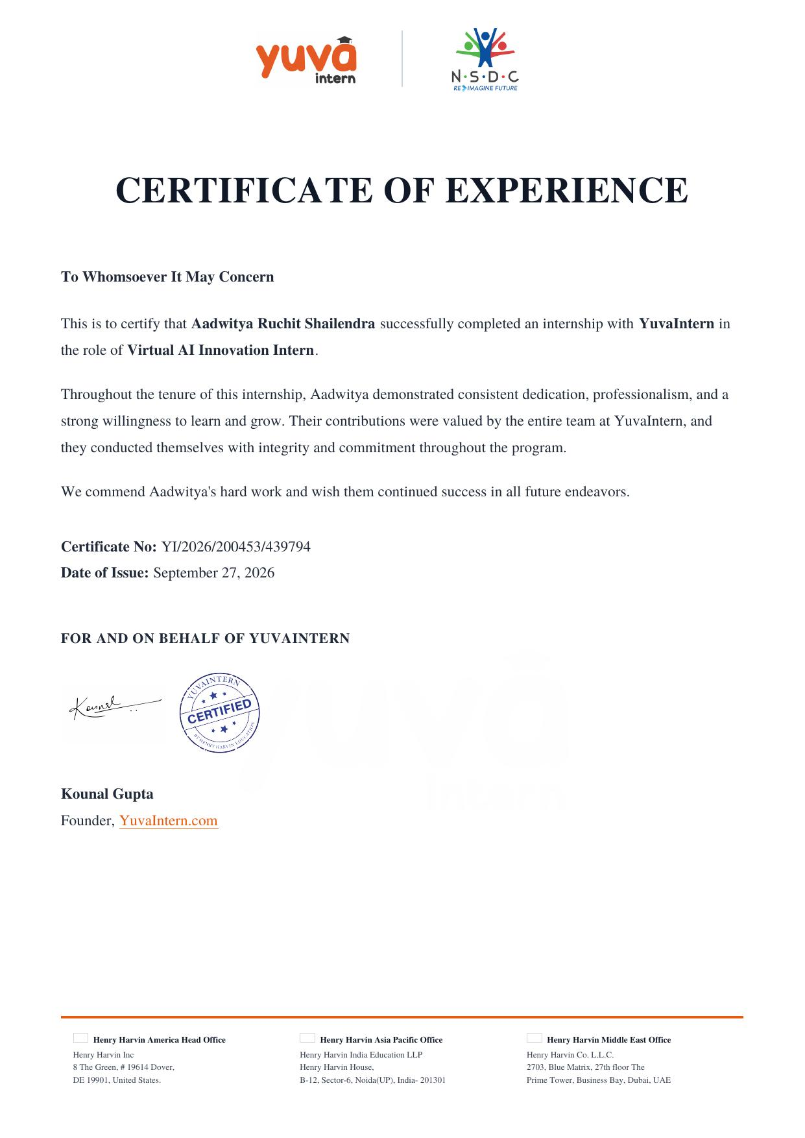

TABLE OF CONTENTS
Chapter No. | Chapter Name | Page Nos.
 | Cover Page | —
1. | Candidate's Declaration | i
2. | Acknowledgement | ii
3. | Internship Completion Certificate | iii
4. | Project Description | 1
 | 4.1 Introduction | 1
 | 4.2 Organization Profile | 2
 | 4.3 Problem Statement | 3
 | 4.4 Project Objectives | 4
 | 4.5 Scope of the Project | 5
 | 4.6 Technologies and Tools Used | 6
 | 4.7 System Architecture | 7
 | 4.8 Methodology | 8
 | 4.9 Expected Outcomes | 13
 | 4.10 Certificates & Communication Proof | 14
5. | Bibliography / References | 16

4. PROJECT DESCRIPTION

4.1 Introduction
Artificial Intelligence (AI) has rapidly evolved from a research discipline into a core driver of innovation across industries, enabling organizations to automate decision-making, extract insights from large volumes of data, and build intelligent systems that support electronics and hardware applications. This report documents the work carried out during a four-week Summer Internship undertaken as a Virtual AI Innovation Intern with YuvaIntern, an initiative affiliated with Henry Harvin and recognized in collaboration with the National Skill Development Corporation (NSDC).
The internship was designed for students with no prior professional experience in AI, with the objective of building foundational skills through real-world, project-based learning. Over the course of the program, the work progressed through four structured phases: (i) formulating an AI innovation strategy and roadmap, (ii) designing an experimental AI prototype, (iii) analyzing data requirements and drafting an implementation blueprint, and (iv) evaluating model performance and proposing an optimization strategy. Together, these phases simulate the complete lifecycle of an applied AI project, from ideation to deployment-readiness.

4.2 Organization Profile
YuvaIntern (YuvaIntern.com) is a virtual internship platform operating under the Henry Harvin group of companies, offering remote, project-based internship programs to students across disciplines including Artificial Intelligence, Data Science, and Electronics. The program is delivered in association with the National Skill Development Corporation (NSDC), which lends structured, industry-relevant learning outcomes to the internship curriculum. YuvaIntern's model focuses on mentorship-driven, task-based learning, allowing students to work on simulated real-world problems under the guidance of experienced professionals, with the aim of building foundational, employable skills in emerging technology domains.

4.3 Problem Statement
Modern electronics and hardware systems generate continuous streams of operational data — sensor readings, usage logs, and performance metrics — yet a large proportion of this data remains under-utilized for proactive decision-making. Faults, inefficiencies, and failures in hardware components are frequently identified only after they occur, resulting in downtime, increased maintenance cost, and reduced product reliability.
The challenge identified for this internship was: how can Artificial Intelligence techniques — specifically machine learning-based anomaly detection and predictive analytics — be applied to electronics and hardware data streams to enable early fault detection, predictive maintenance, and improved operational reliability, while remaining feasible for a student-level prototype built with open, publicly available tools and datasets?
This problem was chosen because it directly aligns with the internship's focus on “assisting in the development and testing of AI-driven solutions, analyzing data patterns, and contributing to innovative problem-solving techniques that support electronics and hardware applications,” and because predictive maintenance is a widely applicable, high-impact use case across manufacturing, consumer electronics, and IoT-enabled devices.

4.4 Project Objectives
- To study current industry trends and state-of-the-art AI techniques applicable to fault detection and predictive maintenance in electronics and hardware systems.
- To design a phased, three-tier (short-term, mid-term, long-term) AI innovation roadmap for integrating AI into the identified problem area.
- To conceptualize and design a small-scale AI prototype, including its architecture, chosen algorithms, and expected workflow.
- To identify suitable data sources, define preprocessing steps, and draft a technical implementation blueprint covering system architecture and data flow.
- To define key performance indicators (KPIs) and an evaluation framework for assessing model performance.
- To identify performance bottlenecks such as overfitting, model drift, and computational inefficiency, and to propose an optimization strategy.
- To document ethical considerations and data-privacy safeguards relevant to deploying AI in this domain.

4.5 Scope of the Project
The scope of this internship project was limited to conceptual design, strategic planning, and prototype-level experimentation rather than full-scale production deployment. It covers: (a) strategic analysis and roadmap design, (b) prototype architecture and pseudocode-level design of an AI model for anomaly detection, (c) data analysis planning using publicly available or simulated datasets, and (d) a performance evaluation and optimization framework. Hardware procurement, live sensor integration, and production deployment were outside the scope of the four-week program and are identified as directions for future work.

4.6 Technologies and Tools Used
- Programming Language: Python
- Machine Learning Libraries: scikit-learn, TensorFlow / Keras
- Data Handling: Pandas, NumPy
- Data Visualization: Matplotlib, Seaborn
- AI Techniques: Supervised learning (Decision Trees, Random Forests), Neural Networks (for pattern/anomaly detection), statistical anomaly-detection methods
- Documentation & Design: Microsoft Word, flowchart/diagramming tools for architecture and data-flow diagrams
- Data Sources: Publicly available sensor/IoT and equipment-failure datasets (e.g., open predictive-maintenance datasets), supplemented with simulated data where required

4.7 System Architecture
The proposed system follows a layered architecture consisting of four stages, designed so that a technical team could subsequently develop it further:
- Data Ingestion Layer: Collects raw sensor/operational data from electronics/hardware sources (or simulated equivalents) at regular intervals.
- Preprocessing Layer: Performs data cleansing, normalization, missing-value handling, and feature engineering to prepare data for model consumption.
- Model Layer: Hosts the trained AI model (e.g., a classification or anomaly-detection model) responsible for identifying abnormal patterns or predicting potential failures.
- Evaluation & Feedback Layer: Monitors model output against defined KPIs, logs performance metrics, and feeds results back for periodic retraining and optimization.
Data flows sequentially from ingestion through preprocessing into the model layer, with evaluation results looping back to inform retraining — forming a continuous improvement cycle rather than a one-time deployment.

4.8 Methodology
The internship followed a structured, week-wise methodology, with each week building on the deliverables of the previous one.
Week 1: AI Innovation Strategy and Roadmap
The first week focused on developing a comprehensive AI innovation strategy for the chosen problem. This began with an executive summary describing the challenge (predictive maintenance for electronics/hardware systems) and the rationale for selecting it, followed by an analysis of current AI trends — including machine learning algorithms and, where relevant, natural language processing for log/report analysis — and their applicability to the problem. A phased roadmap was then designed, covering short-term initiatives (data collection and baseline model development), mid-term pilots (prototype testing and validation), and long-term transformation (scaled deployment and continuous learning), each with estimated timeframes, milestones, and resource requirements. A risk assessment identified obstacles such as data scarcity, model bias, and integration complexity, along with mitigation strategies, and the strategy concluded with a discussion of ethical considerations and data privacy relevant to deploying AI in hardware-monitoring contexts.
Week 2: Prototype Design and AI Model Experimentation
Building on the Week 1 roadmap, the second week translated the strategy into a tangible experimental framework. The problem was restated in technical terms, and a conceptual architecture for the prototype was detailed (data ingestion → preprocessing → model → evaluation, as described in Section 4.7). Candidate AI models — including decision trees for interpretable rule-based classification and neural networks for capturing non-linear sensor patterns — were evaluated for suitability. The anticipated workflow, data processes, and evaluation checkpoints were outlined, along with flowcharts describing the prototype's mechanism. An experimental hypothesis was formulated (that a supervised anomaly-detection model can flag abnormal hardware behaviour before failure occurs), together with the key variables involved and the plan for simulating the model using sample/simulated data, expected outcomes, and potential issue points such as class imbalance between normal and faulty readings.
Week 3: AI Data Analysis and Implementation Blueprint
The third week focused on data requirements and implementation planning. Potential publicly available and simulated datasets suited to the prototype were identified and assessed for quality and relevance, and preprocessing steps — including data cleansing, normalization, and augmentation — were defined. A comprehensive implementation blueprint was then drafted, comprising the system and data-flow architecture described in Section 4.7, along with a description of the training and validation process: feature selection, model tuning (hyperparameter selection), and testing strategy (train/validation/test splits, cross-validation). The blueprint also addressed scalability (handling growing volumes of sensor data), maintainability (modular pipeline design), and security (protecting operational data in transit and at rest).
Week 4: AI Performance Evaluation and Optimization Strategy
The final week evaluated the proposed AI model's performance and defined an optimization strategy. The model's intended functionality was summarized, and an evaluation framework was proposed using KPIs such as accuracy, precision, recall, F1-score, and false-negative rate (critical for fault-detection use cases, where a missed fault is costlier than a false alarm). These metrics were to be assessed via simulated testing using publicly available tools. Potential performance bottlenecks — including model drift as hardware ages, overfitting on limited training data, and computational efficiency for near-real-time inference — were analyzed, and an optimization strategy was proposed involving iterative testing, hyperparameter tuning, and the potential integration of ensemble techniques for improved accuracy, along with recommendations for continuous monitoring and periodic retraining.

4.9 Expected Outcomes
- A documented, phased AI innovation roadmap applicable to electronics/hardware predictive-maintenance use cases.
- A conceptual AI prototype design, including architecture, algorithm selection, and workflow, ready to be handed to a technical team for development.
- A data analysis plan and technical implementation blueprint covering data sourcing, preprocessing, and system/data-flow architecture.
- A performance evaluation framework with defined KPIs and a corresponding optimization strategy for iterative model improvement.
- Strengthened foundational skills in AI strategy formulation, prototype design, data analysis, and model evaluation, directly supporting the intern's transition toward AI Engineering roles.

4.10 Certificates of Completion and Communication Proof
The following documents are attached as proof of the internship offer and successful completion, issued by YuvaIntern.com:
(a) Internship Offer Letter
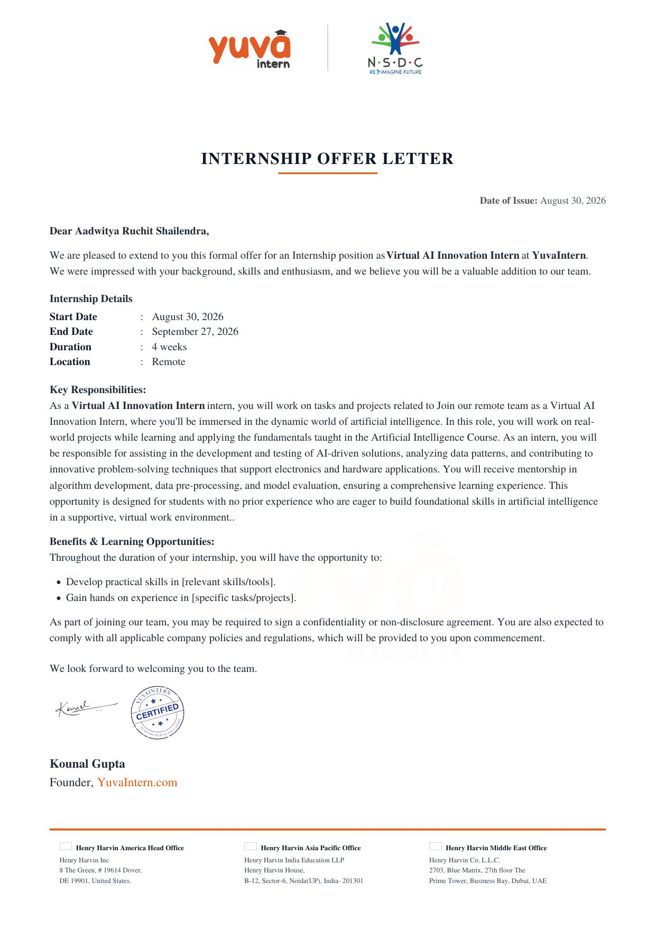
(b) Certificate of Experience

5. BIBLIOGRAPHY / REFERENCES
1. YuvaIntern. “Virtual AI Innovation Intern – Internship Offer Letter.” YuvaIntern.com, 2026.
2. YuvaIntern. “Certificate of Experience – Virtual AI Innovation Intern.” YuvaIntern.com, 2026.
3. scikit-learn developers. “scikit-learn: Machine Learning in Python.” scikit-learn.org.
4. TensorFlow. “TensorFlow: An End-to-End Machine Learning Platform.” tensorflow.org.
5. National Skill Development Corporation (NSDC). nsdcindia.org.

